OAT Tier 1 and Tier 2 Message Flows

Table of Contents
Overview 1
Enrollment Flow 2
Message Flow for all Tier 1 and Tier 2 Enrollees 3
Key Enrollee Flow Items 3
Enrollee Detailed Message Flow 4
Enrollee Flow Diagram 5

Illustration Index
Illustration 1: Enrollment by mail, text or web 2
Illustration 2: Message Flow for all Tier 1 and Tier 2 enrollees 5

Overview
- These message flows support the OAT Tier 1 and Tier 2 use cases
  - enrollment
  - education
  - request for profile information (Zip Code, Disease Interest, etc.)
  - request for measures use cases (HEDIS, A1c)

Enrollment Flow
- Enrollment from USPS forms, Text HEALTHY to 25827 and the web give us different levels of profile information on sign up.
  - Any profile information still needed is gathered via message requests in the Enrollee Message Flow
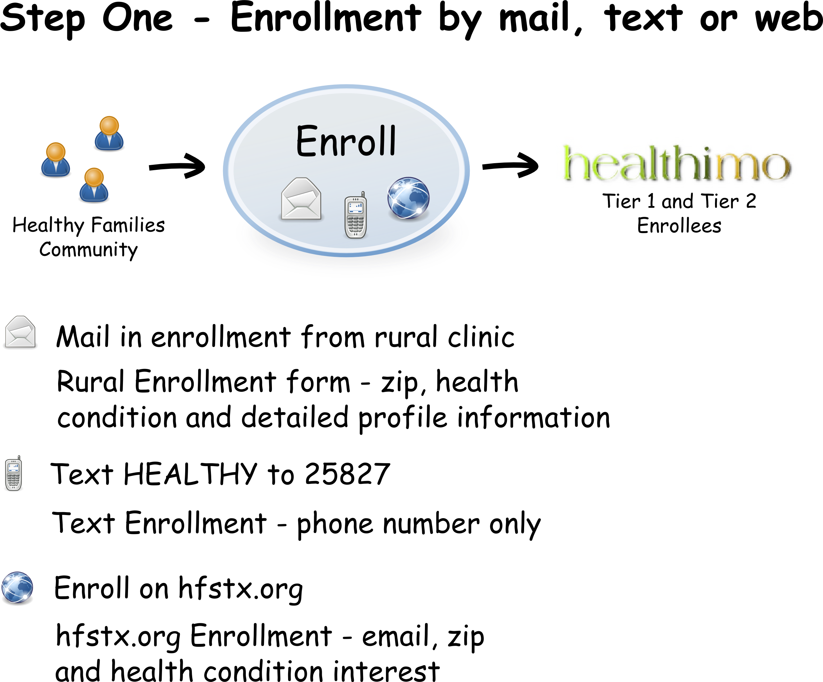
Illustration 1: Enrollment by mail, text or web

Message Flow for all Tier 1 and Tier 2 Enrollees

Key Enrollee Flow Items
- messages to enrollee and any of their self selected supporters
  - usps messages are 1x per month, following same flow
  - for email and text,
    - messages are ~ every four days
  - if zip or disease interest are needed, they are requested ~ every 2 wks
  - requests for information are every 1-2 wks (HEDIS and A1c)
    - via email
    - via usps; education + response form
    - to patient
    - to 'friend'
    - every four days (usps every four weeks)
    - if have disease profile, use that else general wellness

Enrollee Detailed Message Flow
- do we need your zip?
  - (tier 1)
  - general education
  - ask for zip code
  - done
- do we need your disease interest?
  - (tier 1)
  - general education
  - ask for disease interest
  - done
- disease interest is not diabetes?
  - (tier 1)
  - general education
  - done
- disease interest diabetes?
  - (tier 2)
  - diabetes specific education
    - questions that will address self reported HEDIS measures
    - both with education and requests for self reported data
      - % patients > 1 a1c per year
      - % patients w/ highest risk glucose level
      - % assessed for nephrology
      - % receiving a lipid profile once in 2 yrs
      - % with ldl cholesterol of < 130 mg/dl
      - % with blood pressure of < 140/90
      - % receiving periodic dilated eye exam
      - % receiving annual foot exam
      - % receiving counseling on smoking cessation
    - a1c questions
      - HEDIS above for frequency, plus +
      - self reported a1c date and value
  - done

Enrollee Flow Diagram

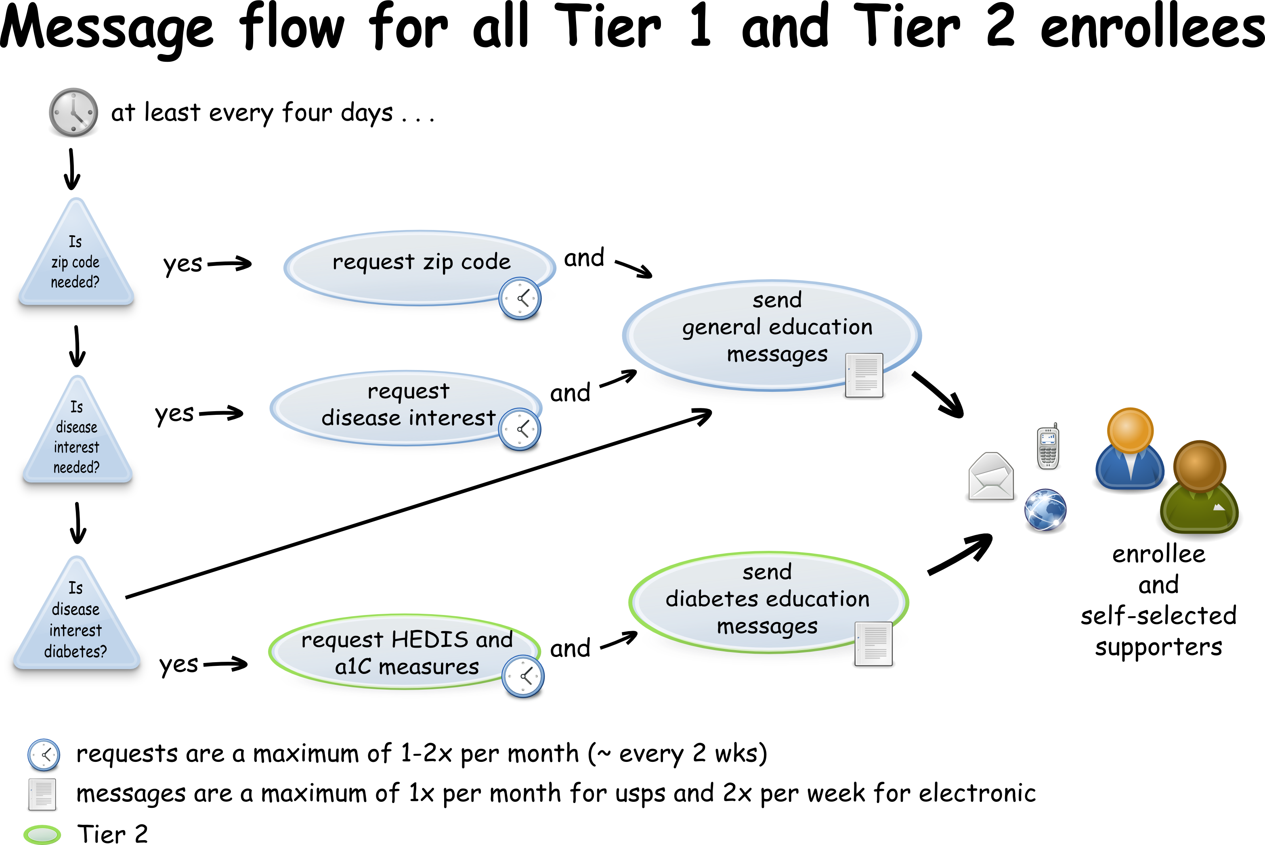
Illustration 2: Message Flow for all Tier 1 and Tier 2 enrollees

